**CASE STUDY 1: JOB DATA ANALYSIS**

**JOB DATA**

Software used: MySQL Workbench 8.0 CE

**Task - 1**

**Jobs Reviewed Over Time:**

* Objective: Calculate the number of jobs reviewed per hour for each day in November 2020.
* Your Task: Write an SQL query to calculate the number of jobs reviewed per hour for each day in November 2020.

Code –

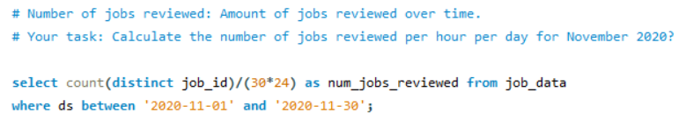

Output –

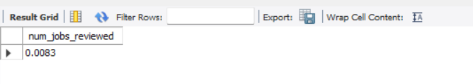

**Task - 2**

**Throughput Analysis:**

* Objective: Calculate the 7-day rolling average of throughput (number of events per second).
* Your Task: Write an SQL query to calculate the 7-day rolling average of throughput. Additionally, explain whether you prefer using the daily metric or the 7-day rolling average for throughput, and why.

Throughput: It is the no. of events happening per second

Code –

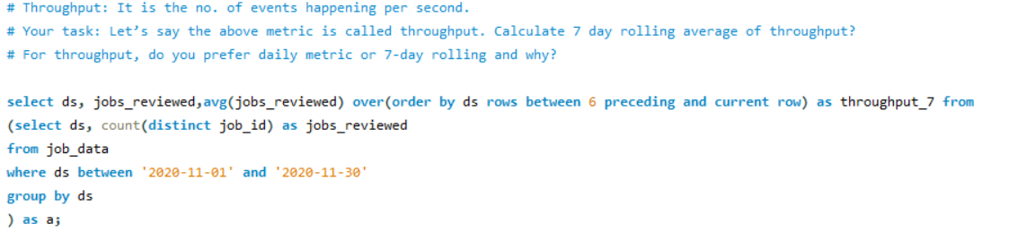

Output –

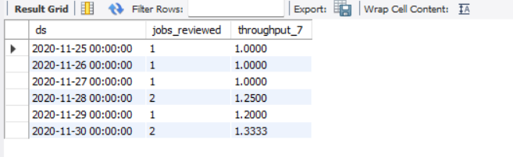

**Task – 3**

**Language Share Analysis:**

* Objective: Calculate the percentage share of each language in the last 30 days.
* Your Task: Write an SQL query to calculate the percentage share of each language over the last 30 days.

Percentage share of each language: Share of each language for different contents.

Code –

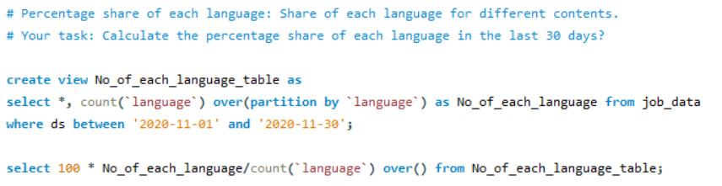

Output –

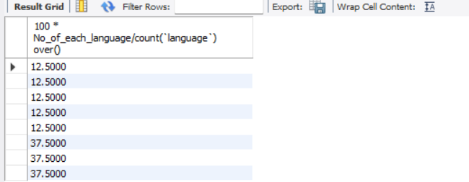

**Task – 4**

**Duplicate Rows Detection:**

* Objective: Identify duplicate rows in the data.
* Your Task: Write an SQL query to display duplicate rows from the job_data table.

Duplicate rows: Rows that have the same value present in them.

Code –

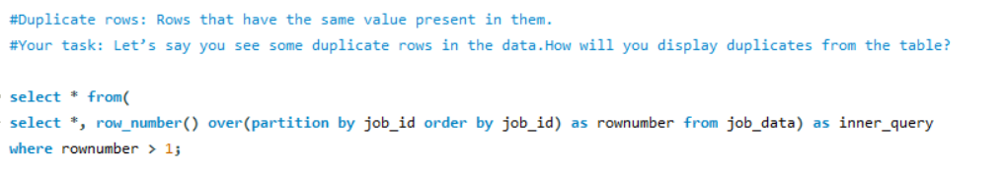

Output –

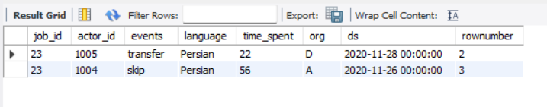

**Case Study 2: Investigating Metric Spike**

**will be working with three tables:**

* **users**: Contains one row per user, with descriptive information about that user’s account.
* **events**: Contains one row per event, where an event is an action that a user has taken (e.g., login, messaging, search).
* **email_events**: Contains events specific to the sending of emails.

**Tasks - 1**

**Weekly User Engagement:**

* Objective: Measure the activeness of users on a weekly basis.
* Your Task: Write an SQL query to calculate the weekly user engagement.

User Engagement: To measure the activeness of a user. Measuring if the user finds quality in a product/service.

Code –

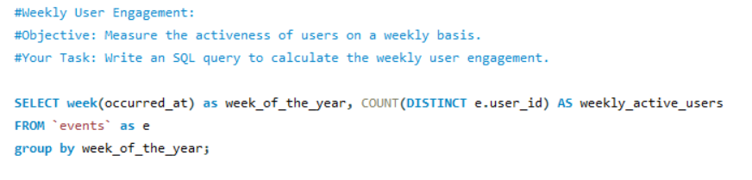

Output –

Output of the task in the below link –



https://drive.google.com/file/d/1X7tdwCwmiHyLoQqjS_CULHB03cLIeroW/view?usp=sharing

**Task – 2**

**User Growth Analysis:**

* Objective: Analyze the growth of users over time for a product.
* Your Task: Write an SQL query to calculate the user growth for the product.

User Growth: Amount of users growing over time for a product.

Growth = Number of active users per week

Code –

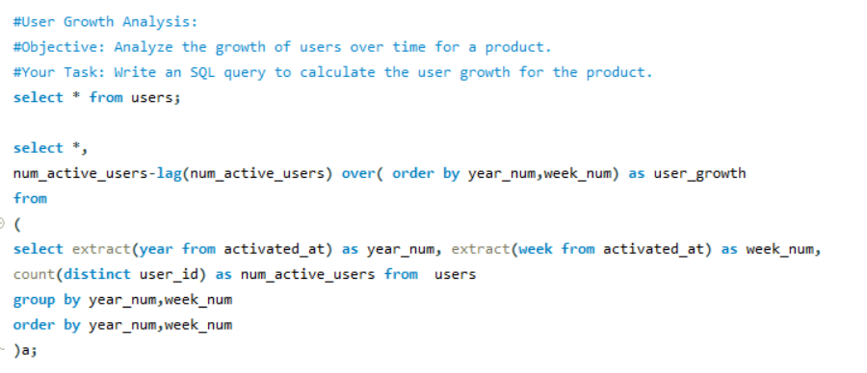

Output –

Output of the task in the below link –



https://drive.google.com/file/d/1k7EMRpnfOSlMEyiDiGL7bIjJSwWVMGWi/view?usp=sharing

**Task – 3**

**Weekly Retention Analysis:**

* Objective: Analyze the retention of users on a weekly basis after signing up for a product.
* Your Task: Write an SQL query to calculate the weekly retention of users based on their sign-up cohort.

Weekly Retention: Users getting retained weekly after signing-up for a product.

Code –

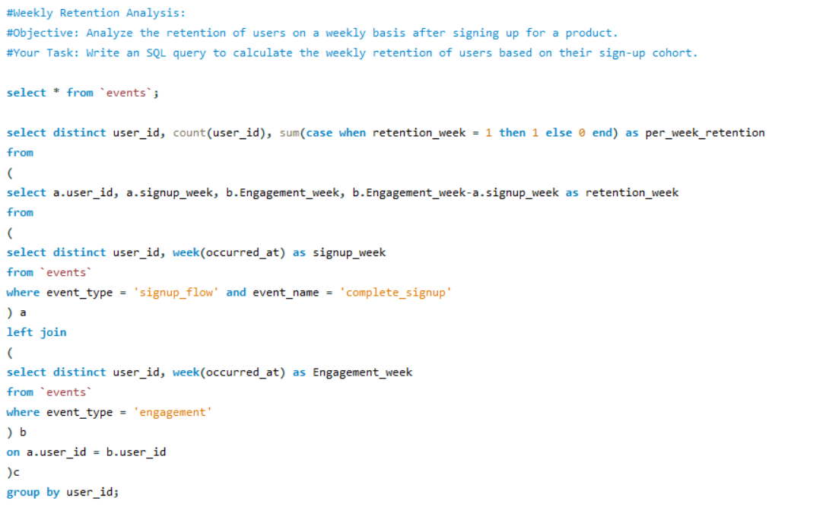

Output –

Output of the task in the below link –



https://drive.google.com/file/d/1HqpYU12gJbMPlXTIy2RK10xbhRZBpiY9/view?usp=sharing

**Task – 4**

**Weekly Engagement Per Device:**

* Objective: Measure the activeness of users on a weekly basis per device.
* Your Task: Write an SQL query to calculate the weekly engagement per device.

Weekly Engagement: To measure the activeness of a user. Measuring if the user finds quality in a product/service weekly.

Code –

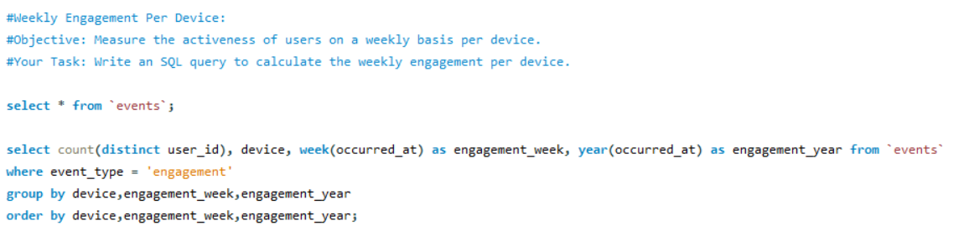

Output –

Output of the task in the below link –



https://drive.google.com/file/d/1_AfH-rqYQ9jYRh3VI-Joju3dUnJKrJjB/view?usp=sharing

**Task – 5**

**Email Engagement Analysis:**

* Objective: Analyze how users are engaging with the email service.
* Your Task: Write an SQL query to calculate the email engagement metrics.

Email Engagement: Users engaging with the email service.

Code –

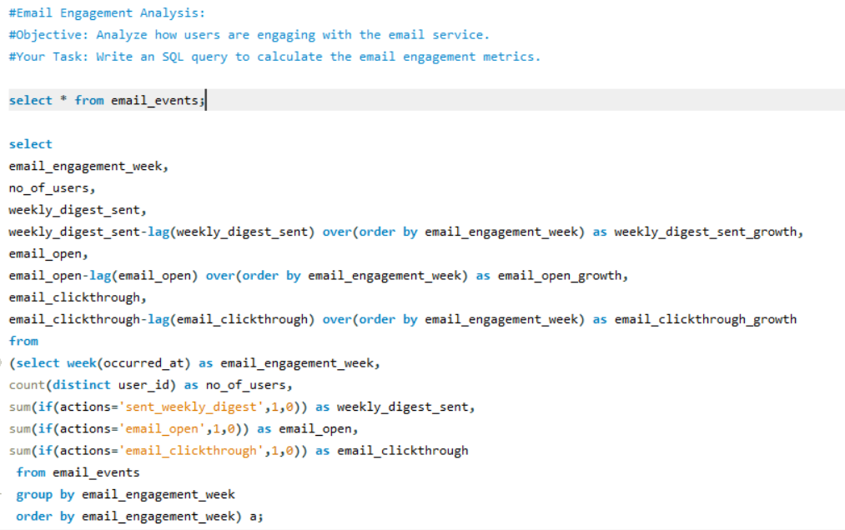

Output –

Output of the task in the below link –



https://drive.google.com/file/d/1H3fn8AYn_Jrf6ixHt_Uiv1GczYwcnpOK/view?usp=sharing